**Employment Growth in U.S. Healthcare and the Future of Cost Containment**

11/19/15

1225 Words

In 2013, the growth rate in U.S. healthcare spending was the lowest in 50 years, and real per capita Medicare non-drug expenditures actually declined (Krumholz et al. 2015). Health policy experts and the media viewed the “unprecedented” drop as demonstrating that, at last, healthcare cost growth had been tamed (Young 2014). The one number that didn’t fit with this popular narrative was employment growth in the healthcare sector. In 2013, healthcare jobs continued to grow at 1.5%, only slightly below the post-2000 average of 2.2%. Because salaries and wages account for roughly 60% of total healthcare expenditures, it seemed unlikely to some that the U.S. could really have turned the corner on unrestrained healthcare costs without a corresponding moderation in employment growth (Chandra et al. 2013).

Since that time, job growth has accelerated. According to the Altarum Institute, the healthcare sector has added 2.2 million jobs, more than the 2.1 million jobs added by all other sectors of the economy. More than one-fifth of these new healthcare jobs were added in the first 10 months of 2015 (Altarum 2015). That the healthcare sector is an engine of job creation is great news for the macroeconomy. Yet should we be worried that the job growth signals an inevitable return to double-digit healthcare cost growth, ever-widening deficit spending, and an early bankruptcy of the Medicare program?

We bring good news and bad news. The good news for healthcare costs is that there is little short-term association between employment growth and healthcare spending. Figure 1 shows the growth in healthcare employment (with 2000 the base year), the growth in non-healthcare employment, and inflation-adjusted per-capita healthcare costs. There has been remarkably stable growth in healthcare employment, in sharp contrast to non-healthcare employment. The smooth growth in healthcare jobs, however, is quite distinct from the variable growth patterns in healthcare expenditures, which includes rapid growth in the early 2000s before a moderation after 2006, the 2013 slowdown, and accelerated growth since then. There is nothing from this graph (nor more formal statistical tests) to suggest that healthcare employment growth is a short-term harbinger, or a lagging indicator, of healthcare cost growth.

In other words, these associations suggest that the rising employment growth won’t signal higher healthcare costs right away – the good news. It would be bad news, however, if this hiring percolated up into healthcare spending during the next half-decade. But perhaps employment measures are simply too crude to capture changes in wage and salary compensation. For example if physicians are replaced by home health aides, we could find employment expenses falling even while the number of workers are increasing. Another possibility is that the gains in employment have occurred because of one-time increases in administrative costs, so that recent job growth was the consequence of non-clinical billing specialists, lawyers, or management positions such as vice presidents.

To consider these two hypotheses, we tabulated the change in occupational employment, and overall employment, in healthcare between 2000 and 2014, shown in Table 1. The estimate of total employment comes from the Bureau of Labor Statistics Current Employment Statistics, while occupation is from U.S. Census data; thus they are not perfectly comparable. (For example, a physician who works for an insurance company would be categorized in the financial services sector, not the healthcare sector.) Still, the comparisons are informative. During 2000-2014, overall healthcare employment grew by 2.2% annually. Health aides grew substantially faster, by 4.0% annually, yet physicians (2.4%), nurses (3.4%) and other clinical professions (3.5%) grew at a more rapid rate than overall job growth in the entire healthcare sector. It’s not administrative workers driving healthcare employment growth.

More troubling still is that our estimates of healthcare employment growth are almost certainly underestimates of the true growth in jobs arising from growing demand for healthcare employment. For example, if the hospital contracts out its food services, or buys a new electronic records system, the resulting new food preparation and programming jobs show up in some other sector of the economy, not in healthcare. This is why the conventional healthcare “sector” is only about 11% of GDP, while healthcare spending is closer to 18%.

Controlling cost growth is a central motivation behind the Affordable Care Act (ACA). There are a variety of cost-saving approaches to reducing utilization, including bundled payments and Accountable Care Organizations (ACOs). Others propose restructuring healthcare delivery by changing where and how patients get care. While they are all designed to reduce costs, they may paradoxically add to employment growth. Employees of hospitals and clinics are busy, and they don’t have time to effect cost-saving innovations – thus requiring new employees to implement them. It’s certainly possible that the innovations will lead to longer-term trimming of positions by reducing redundancy and inefficiency, but at least in the aggregate, we have not yet seen this effect take hold.

Our unpleasant arithmetic illustrates the downside of bending the cost-curve – reduced employment growth, and possibly job loss in the health sector, with the effects affecting most heavily those states and regions most dependent on healthcare. This would require a major change in the healthcare industry. Through two major recessions, the U.S. health services sector continued to grow and add employees. No other sector can boast such stable growth rates. Any improved cost control, whether through the mechanisms included in the ACA or through other policy changes, necessarily requires a slowing of the growth that has protected healthcare workers and sectors from painful reorganization. In the past, even as we have seen a large shift away from hospitals and into home health, layoffs and restructuring have been largely avoided because overall growth was fast enough to prevent any one sector from contracting in absolute terms. If effective cost control is to be a reality, this growth in jobs will have to slow.

The reality is that, unlike every other major industry, the health sector has never had to resort to layoffs to make fundamental structural changes. This continued job growth is partially because of structural forces: the health services sector is characterized by ever-new technological innovations, is highly labor-intensive, cannot be outsourced, is hard to automate (particularly in fast growing sectors like home healthcare), and has been able to pass along rising costs to third-party payers and consumers. Unlike retail and manufacturing industries, where computers are replacing humans, computerized medical records have only added to the required human workload, whether it is physicians and nurses spending more time tapping on the keyboard, or hiring 21st century scribes to follow them around.

We don’t mean to fall into the typical economist’s role of eternal pessimist. Instead, we are suggesting that for system-wide change, one key focus should be on the Human Resources department. Short-sighted policies like hiring freezes are unlikely to be successful, since they simply freeze in place outmoded worker allocations, preventing the hiring of needed workers, and sometimes leading to increased strains on existing employees. Instead, the focus should be on restraining overall hiring by “right-sizing” jobs to employees who can best perform them, and at lowest cost. Now that the current labor market is reawakening after nearly a decade of slumber, there’s an opportunity to let other sectors of the economy become the engine of employment growth. It’s perhaps not a pleasant future, but surely preferable to one in which Medicare, Medicaid, and the ACA collapse under the weight of ever-rising healthcare costs.

References:

Altarum Institute, 2015. *No moderation in hospital and health sector job growth*,

Chandra, A., Holmes, J. & Skinner, J., 2013. Is This Time Different? The Slowdown in Health Care Spending. *Brookings Papers on Economic Activity*, pp.261–302.

Krumholz, H.M. et al., 2015. Mortality, Hospitalizations, and Expenditures for the Medicare Population Aged 65 Years or Older, 1999-2013. *Jama*, 314(4), p.355. Available at: http://jama.jamanetwork.com/article.aspx?doi=10.1001/jama.2015.8035.

Young, J., 2014. U.S. Experiences Unprecedented Slowdown In Health Care Spending. *Huffington Post*. Available at: http://www.huffingtonpost.com/2014/12/03/health-care-spending_n_6256166.html [Accessed November 20, 2015].

Here is the data you requested. All numbers are annual averages in thousands of employees, and most of the states had data for both “Social Assistance” and “Health Care and Social Assistance” from 1990 to 2015.  There are a number of exceptions:

1. Iowa, Kansas, Mississippi, Nevada, New Hampshire, South Carolina, South Dakota, and West Virginia did not have data for "Social Assistance" on its own, only "Health and Social Assistance" together. I left the underlying data for these in the spreadsheet but I did not include these states in the master data table.

2. New Mexico did not have data for either of these categories; instead, they only report "Education and Health Services" as a whole. I also left the underlying data in the spreadsheet, but did not include New Mexico in the master data table.

3. Kentucky and Michigan only have "Social Assistance" data from 2001+

4. Wisconsin only has “Social Assistance" data from 1995+.

5. As you mentioned, Alaska had a separate “Health Care” category, and only had data from 2003+.

As a result, 41 states are found in the master data table, and 4 of them do not have the full 15 years of data.

Please let me know if you want anything in a different format, you see any issues, or you have any questions.

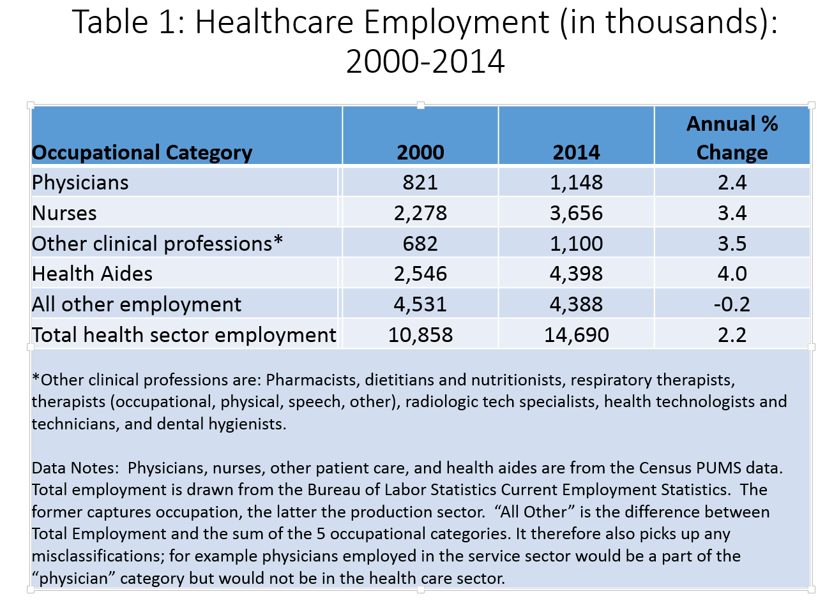

Figure 1:

